Welcome to the Georgian Bay Rowing Club

Member Handbook

Updated 2023

TABLE OF CONTENTS

WELCOME

Daily Procedures

Expectations

Hours of Operation

Rowing Opportunities

Sign-Up

Designated Adult

Club Procedures

VOLUNTEER EXPECTATIONS

GENERAL SAFETY

Traffic Map

Cold Water Rules

Safety Video

Swim Competency

EMERGENCY ACTION PLAN

CODE OF CONDUCT

SAFE SPORT

PRIVATE EQUIPMENT STORAGE POLICY

CONFIDENTIALITY POLICY

VOLUNTEER AND STAFF CONFIDENTIALITY AGREEMENT

IMAGE CONSENT FORM

CONCUSSION

Sign-Off Sheet

Glossary of Terms

Appendix A

## WELCOME

Welcome to the Georgian Bay Rowing Club located in Midland, Ontario with a satellite location in Gravenhurst. Established in 1984, we have been providing rowing opportunities for members of the community on Little Lake and surrounding areas for both recreational, competitive youth and competitive masters oarspeople. Being a member of GBRC gives you access to the club house and all of its club owned equipment. We encourage all members to explore opportunities offered in our club community.

### Daily Procedures

Equipment needed - change of clothes, wear workout clothes (specific to weather conditions of the day), dress in layers (in applicable weather), water bottle, snack, hat, low cut running shoes/sandals. Please be aware clothing, shoes and other personal belongings may get wet and/or covered in grease.

As we are a not-for-profit, volunteer-based organization we will need members to help out at the club on a daily basis in order to open the doors.

There may be a student on staff beginning in June to drive a coach/safety boat during member row times but we will need an adult member to agree to be a ‘Support’ for each row session for safety reasons. If we don’t have someone designated (using the online spreadsheet) , the club may not be able to open during that session.

Before rowing, all members must be registered with one of the following programs:

* Adult Membership *(including anyone storing a private shell in the boathouse);*
* Youth Membership *(students);*
* Associate Membership *(anyone already registered with another club AND has already paid their RCA and RowON fees for that year);*
* Adult Learn-to-Row;
* Youth Learn-to-Row *(ages 13-18);*
* Row-a-Month *(30 days of Rowing);*
* Coxie;
* Composite *(visitor; one time rowing)*
* All payments to be done via e-transfers to [georgianbayrowingclub@gmail.com](mailto:georgianbayrowingclub@gmail.com)
* Private boat owners must pay a full membership for boat storage at the club and either have private insurance - club insurance does not cover private boats.
* Learn-to-Row and Row-a-Month members are eligible to upgrade to full youth or adult membership. Prices are listed on our [website](https://georgianbayrowing.wixsite.com/gbrc/golf-shop).
* All members must have completed on-water rowing lessons (i.e., a learn-to-row), either at GBRC or other clubs in order to row at regularly scheduled row times. If a club staff or a coach has concerns about safety or use of equipment, the rower may be asked to complete a learn-to-row before continuing to row

### Expectations

* Sign up in advance for a row time using spreadsheet (need 3 or ideally 4 people including staff member to get safety boat launched on and off the water)
* Plan on being an adult Support member for safety reasons throughout the on water season. Support person will open the clubhouse and may have boats/oars pre assigned on whiteboard. Support or Coach Boat driver member may drive a safety boat for member rows unless an approved, qualified member volunteers to drive.
* On arrival help launch safety boat if needed
* Support member will indicate traffic pattern for the day
* Support member will have a whiteboard with assigned boats and oars completed.
* Take assigned oars to dock
* Get a club labelled stroke coach, if needed, from the stroke coach hub at back of boathouse
* Assist others as needed (support can direct)
* Put your boat on stretchers outside of the boathouse and check rigging, heights and footstops.
* Carry boat to water
* Launch and wait on water near dock for all other crews to be on the water including the safety boat
* Support member will lock the boathouse during row and put barriers across the dock to indicate that dock and area are closed and in use by GBRC at this time.
* Row according to designated traffic pattern for the day
* When finished row, remove equipment from water with assistance if needed. Support will open the boathouse. Put your boat on stretchers outside of the boathouse and wipe down all surfaces of hull/rigging of boat and oars.
* Return equipment to designated racks (boats will often have markings on their gunnels for position on rack, make a note of positioning before leaving the boathouse to ensure boat is returned to correct position)
* Return and plug in (if needed) Stroke Coach to hub
* Help others, if needed
* Help return the safety boat to the boathouse on dolly
* Ideally, complete a volunteer job - i.e. inside or outside boathouse clean up (see list - i.e. rake , tidy, take out garbage or recycling , clean…)

### Hours of Operation (tentative) and subject to change ):

5:30- 7:15 am Competitive open training row

Not a member row; Coach -

7:15- 9 am member row

Staff plus adult in charge plus 2 members

5:45- 7:30 pm member row

Staff plus adult in charge plus 2 members; Jr development program - May/June LTR - June

* Row times may be altered due to weather, daylight or events

Link to Sign-up Sheet to be provided upon registration.

Non Scheduled Rows: Experienced, private boat shell owners and approved members may on occasion make arrangements with a board member to row outside of scheduled member row times depending on water/weather conditions. Safety equipment must be carried in their shell, members assume responsibility for their own safety.

Cold water rules apply (if water temp is 15 degrees or cooler)

Arrangements to open the club must be made with a board member - Club keys will be distributed to board members and staff only.

Offseason Rowing (i.e., pre-docks in, post-docs out, and before regular club hours begin in the spring) will only be offered to rowers who have been approved by the board. The requirement for approval being, ability to row without safety concerns, ability to swim, and being a member in good standing. Before getting on the water in the spring, all members must be registered with RCA, read and sign off on the handbook and have paid their fees. All safety rules will be observed, including cold water rules and there will only be rowing if there are enough people for safety to be assured.Coaches/board members make the final call for if a row can occur under these conditions and members have to accept the decision.

### Rowing Opportunities

Members have the ability to choose to row recreationally and/or competitively. Choosing to row one or the other does not exclude you from changing your mind at a later time. GBRC encourages all members to row what they are most comfortable with.

For recreational members who are looking to get into rowing competitively, we recommend your first regatta to be our regatta, the Muskoka Fall Classic (typically the second Saturday of September) or Head of the Trent (in October).

Competitive oars people have the choice to row Open or Masters. Open sprint races are 2000m, while Masters sprint races are 1000m. Head races for Open and Master vary depending on the race.

### Sign-Up

Upon signing up for your program, you will receive an email with the link to sign up for daily row times. The link will bring you to a Google Docs, which will be updated weekly. Sign up for desired times as many times a week as you would like, based on the schedule above. Please sign up as early as possible to allow for staff to have time to plan the session, and if you are unable to make a session you signed up for, please notify staff.

If a time slot is “blacked out” it means the rowing session is not running at that time. Each time slot will have a section for a “designated adult,” please plan to sign up in one of these slots once a week. If there is not a “designated adult,” the session will not run.

If a session is cancelled, you will be contacted with as much notice as possible. A session can be cancelled for any number of reasons, including but not limited to, weather, not enough people signed-up, special events, etc

### Designated Adult

To comply with new Safe Sport regulations, GBRC is implementing a designated adult program to meet the requirements for the “Rule of Two.”[1] The Rule of Two stipulates that in all interactions between coach and athlete, a third party must be present to ensure all interactions are observed and conducted in a professional manner.

The designated adult will act as a set of eyes and ears for the members of the club during the row time they signed up for. If coaches are having discussions with athletes or people congregating on the dock or inside the compound the designated adult would observe and offer support.

The designated adult will also act to assist club staff. If there are safety concerns, they have a responsibility to make sure they are handled effectively.

We ask that all members consider being a designated adult once a week. The designated adult is able to row, or drive a coach boat (if they have been approved by the board), but must take into account the safety of all members and staff.

### Club Procedures

In this handbook, you will find the following procedures,

* Volunteer Expectations
* General Safety
* Emergency Action Plan
* Code of Conduct
* Safe Sport
* Private Boat Storage
* Confidentiality Policy
* Media Release
* Concussion Policy

Please take the time to read through them. Before rowing, all members are required to complete the sign-off sheet, and submit it, and any questions, to [georgianbayrowingclub@gmail.com](mailto:georgianbayrowingclub@gmail.com).

All members must be registered, and paid before they are able to go on the water. All payments to the club are to be paid via e-transfers to [georgianbayrowingclub@gmail.com](mailto:georgianbayrowingclub@gmail.com) or cheque, when applicable.

## VOLUNTEER EXPECTATIONS

As a volunteer based organisation, GBRC asks all members to sign up for one of the following committees to facilitate the running of the club on a daily basis.

To sign-up for one of the following groups, email [georgianbayrowingclub@gmail.com](mailto:georgianbayrowingclub@gmail.com).

* Muskoka Fall Classic Committee: Help with the organisation of our fall regatta. Responsibilities to attend all committee meetings leading up to the event (virtually) and complete tasks as assigned by the regatta chair.[2]
* Maintenance Committee: Assist with the daily and scheduled maintenance of the clubhouse, dock and trailer. Main duties include organising docks in/out and workdays.
* Social Committee: Assist with the organisation of social events for the club, such as fundraisers, get togethers, end of year events, etc.
* Youth Program Committee: Assist with the organisation, recruitment, and running of high school/junior programs.
* Competitive Master Program Committee: Assist with coaching and planning of regattas to attend by Masters group.
* Summer Learn-to-Row Committee: Help to coordinate and run summer learn-to-row programs.
* Camps & Clinics Committee: Assist with the organisation and running of special camps and clinics, such as annual Purcerverance Clinics and the True North Rowing Camp.
* Severn Site: Assist with monitoring and managing equipment at the satellite Severn River location.

All club members are asked to attend docks in and docks out, any additional workdays, and the Muskoka Fall Classic. These events require a large amount of people to get work done safely and effectively. Additionally, the work done positively impacts all club members.

## GENERAL SAFETY

### Traffic Map

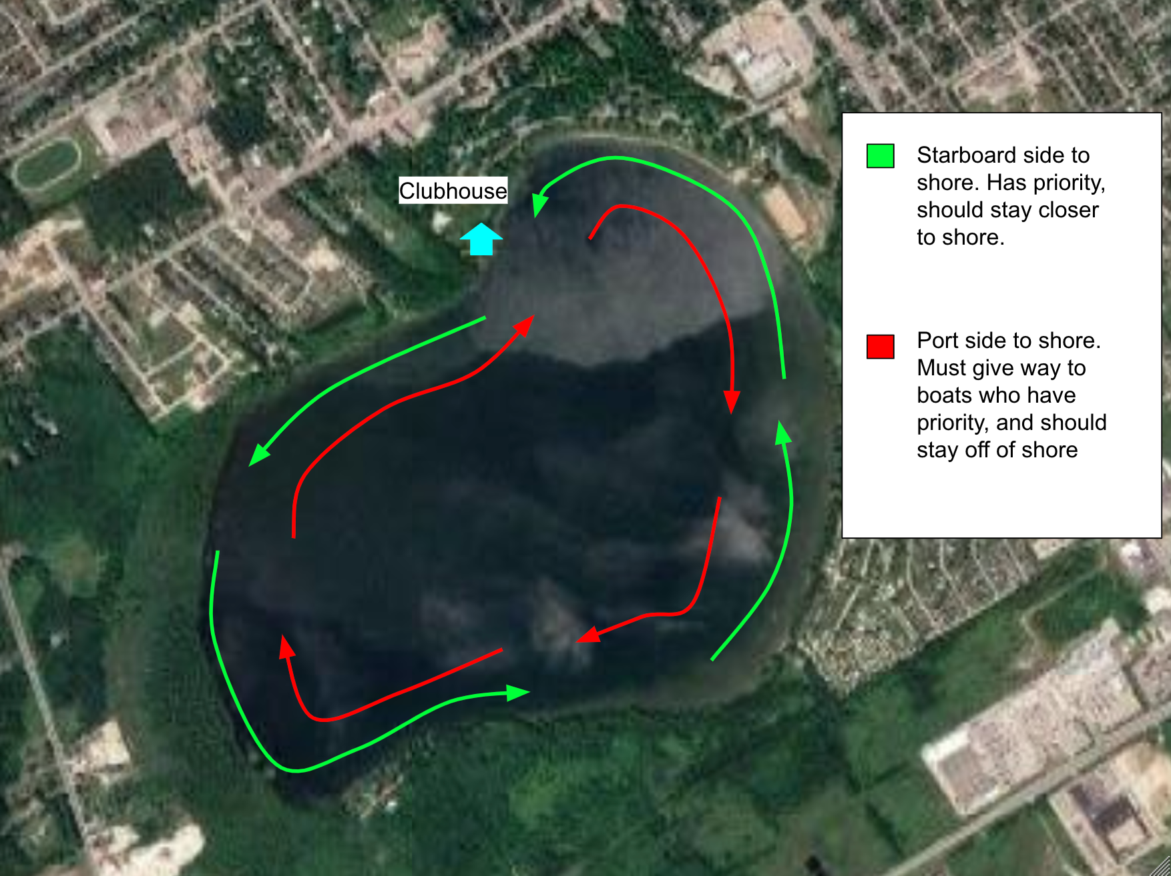

Rowing at points can be dangerous. Propelling oneself backwards, can lead to collisions with other rowers and other obstacles. Little Lake also hosts fishing boats, kayaks, SUPs, canoes, swimmers, docks, and animals like swans and geese that could get in your way. Most of these obstacles will be able to see you coming, while you may not be able to see them coming. For other rowers on the lake, you may not be able to see each other coming.

We ask that all rowers follow the above traffic pattern to mitigate many accidents. While rowing, most rowers will follow the green pattern, shown above. One will have their starboard side to shore, and are to stay closer to shore. If you are being overtaken by another rower, give them right away and move aside when applicable. If you are overtaking another rower, you should pass on the shore side of the rower, i.e., pass between them and the shore.

For those following the red traffic pattern, with their port side to shore, they must give way to boats going the other way. These rowers should be further away from shore to not interfere with rowers doing the other traffic pattern.

If a rower needs to cut across the middle of the lake for any reason, they must give way to other boats and only do so when it is safe.

All rowers must have an awareness of their surroundings, regardless of which traffic pattern they are following. Before rowing, check the lake for potential obvious obstacles (i.e., anchored fishing boats), check with club staff for any new obstacles (i.e. logs in the water after a storm), and be aware of the weather (i.e., potential for a storm). If you encounter an obstacle that club staff is not aware of, make sure you let them know promptly. If you are new to the club, make sure to ask for important landmarks on the lake (i.e., where to go if there’s a storm, where is it most shallow, etc.).

Good practices for rowing safely include wearing bright coloured clothing (the more neon, the better!), having a whistle or your phone (in water-safe storage) with you, having a life-jacket (when applicable), staying close to the safety boat, and rowing as a group.

On windy days, the entire lake might not be rowable. Make sure you check with club staff to see which portions of the lake you are able to row on. If you are only able to row on a portion of the lake, it is even more important to follow the proper traffic pattern.

If a storm rolls in, especially with lightning, try to get to the dock as fast as possible. If you can’t get to the dock, find a property with water access (i.e., a beach or a dock) to wait it out. If you see lightning, make sure you let club staff know.

### Cold Water Rules

Rowing Canada requires we have protocols to protect crews from the risk of exposure to cold water. Preparation and prevention are essential in protecting against the effects of the cold-water environment. As per RCA if the water temperature is below 15 degrees Celsius cold water rules shall apply. Some considerations are:

* Wearing protective clothing appropriate for the conditions and the activity. Select materials in clothing that allow the body to stay dry and insulated against heat loss but with flexibility for the rowing motion and activity

GBRC Cold water rules are:

* Coach/ safety boat will be on water for club scheduled rows.
* A coach boat must be on the water with junior (under 18) programs or learn to row programs
* Experienced crews, approved by the board are able to row without a coach boat so long as the “Four Oar Rule” is observed, (any row must have a minimum of four oars on the water, a 2x or a 4-/+ are the smallest boat allowed). Exceptions may be made for private boat schell owners rowing with their own equipment. Private boat shell owners will assume responsibility for their own safety and the safe operation of their personal equipment.

### Safety Video

For an in depth explanation of rowing safety, check out this safety video from RCA: <https://youtu.be/AJ_s5iBZy1c>

### 

### Swim Competency

Rowing is a safe activity, but dangers can arise with poor weather, other obstacles on the water, and with fatigue. Going in the water can happen to new rowers and experienced rowers. Club staff and coach boat drivers are there to ensure rowers’ safety, but it is essential for them to know if you are unable to swim in case an emergency arises. For this reason, we ask that all members attest to the following by signing the sign off sheet:

I can:

* Swim 25 m
* Tread water 1 min
* Put on life jacket on deep in water

If you are unable to do any of the above, do not sign the swim competency section of the sign off sheet. It is your responsibility and requirement to inform club staff and/or coaches before rowing if you are unable to do any of the above. GBRC will do everything we can to accommodate non-swimmers (i.e. wearing a life jacket when rowing).You can also email [georgianbayrowingclub@gmail.com](mailto:georgianbayrowingclub@gmail.com) if you are more comfortable.

## EMERGENCY ACTION PLAN

In Case of Emergency Call 911

Georgian Bay Rowing Club

783 Little Lake Park Road

Midland, Ontario

L4R 2E1

Directions coming from the East -

Take Highway 93 North to Midland

Turn right onto Yonge Street in Midland

Turn right into the park.

Take the first right in the park into the skatepark, before the ball diamond.

Directions coming from the West-

Take Hwy 12 East to King St.

Take King St. North to Little Lake Park Road.

Take Little Lake Park Road through the park

Turn left past the ball diamond at the skate board park.

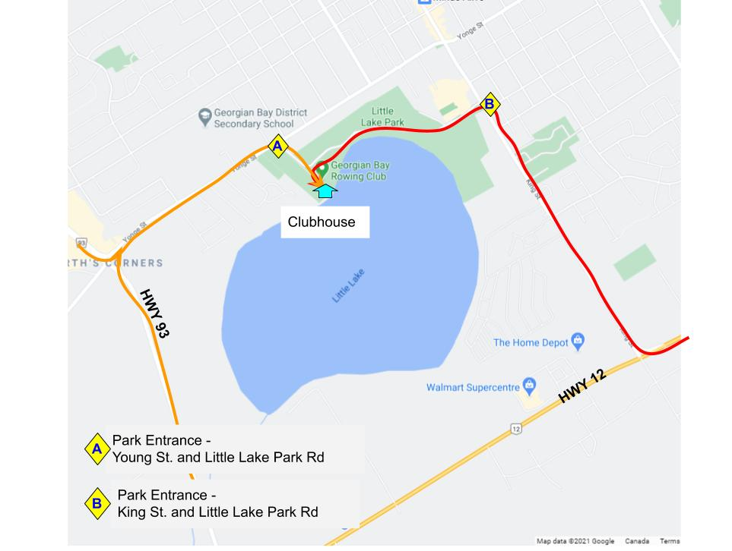

Layout of Location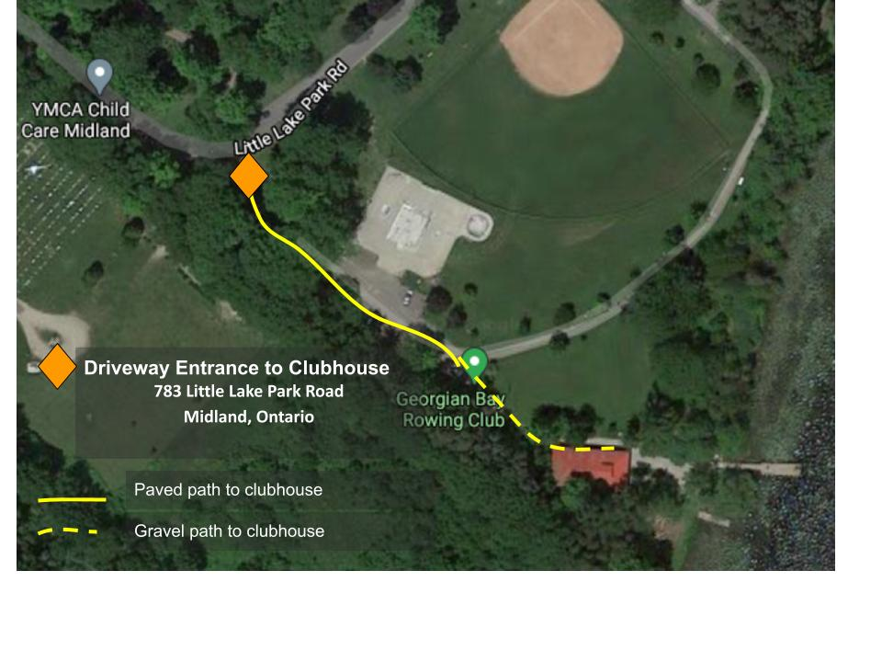

* Phones: personal cell phones in the clubhouse. Coach/staff will have phone on them on the water
* No AED on site
* First Aid kit in the clubhouse
* Emergency meeting place: in front of the clubhouse

Club Emergency Procedures indicate that EMS should be contacted if any of the following situations occur:

* Victim is not breathing or was not breathing
* Victim is bleeding profusely
* Victim lost consciousness for any period of time
* Injuries occur to back, neck or head
* There is a major trauma to a limb
* Victim suffers cold water emergency
* Serious assault with or without a weapon
* Fire
* Any other situation at the discretion of the Charge Person on site at that time

**ROLES IN AN EMERGENCY**

**In Charge Person**

* Lead Coach, staff or senior volunteer on site with First Aid training
* Monitors possible danger to themselves and others
* Responsible for first aid – including decision to contact EMS and victim care
* Direct others to complete assigned tasks (see below)
* Needs to know location of Emergency Information for all participants and be able to access
* Ensure Incident report is completed and appropriate follow up is completed including alerting *Club President/ Senior Person*

**Call Person**

* As directed by charge person call EMS
* Have knowledge of situation to be able to communicate details to EMS
* Have knowledge of site to communicate directions to 911 Operator

**Other Roles to be Assigned**

* Greet EMS at site entrance
* Runners to get First Aid Kit, AED, ice, blankets etc.
* Ensure everyone else gets off the water immediately and stays off the water
* Controls the crowd

## 

## CODE OF CONDUCT

All Georgian Bay Rowing Club (GBRC) members, before commencing practices with the GBRC will commit to the following Code of Conduct.

1. Members of GBRC and participants in club programs and activities are expected to conduct themselves at all times in a manner consistent with the values of GBRC.
2. Athleteshave a responsibility to maintain and enhance the dignity and self-esteem of members and participants of GBRC by:
   1. Demonstrating respect to individuals regardless of gender, ethnic or racial origin, sexual orientation, athletic potential, age, marital status, religion, political belief, ability/disability or economic status, medical status.
   2. Acting, when appropriate, to prevent or correct practices that are unjustly discriminatory
   3. Focusing comments or criticism appropriately and avoiding public criticism of fellow athletes, coaches, umpires, organizers, volunteers, employees and members
   4. Consistently demonstrating the spirit of fair play, sport leadership and ethical conduct and practices
   5. Maintaining and protecting members’ and participants’ right to privacy
   6. Interacting with others in a way that enables all individuals to maintain their dignity and respect
   7. Consistently treating individuals fairly and reasonably
   8. Ensuring that the RCA Rules of Racing, and the spirit of such Rules, are adhered to.
3. Adhere to GBRC’s position with respect to the use of tobacco while participating in GBRC events.
4. Abstain from the non-medical use of drugs or the use of performance-enhancing drugs or methods, as set out in RCA’s Anti-Doping Policy.
5. In recognition of the potential seriousness of a concussion, all athletes (and their families) commit to following the concussion policy including:

* Review the concussion policy, and educational resource materials as provided
* Support a zero tolerance for behaviours that are associated for high risk of causing concussions
* Open and honest communication with GBRC personnel about any concussions or suspected concussions obtained through involvement with rowing or any other activity outside of rowing

1. Refrain from any behaviour that constitutes harassment, where harassment is a form of discrimination and is defined in the Ontario Human Rights Code as “a course of vexatious comments or conduct that is known or ought reasonably to be known to be unwelcome.” While this applies to any form of harassment, the Ontario Human Rights Code specifically prohibits harassment on the following grounds: race, ancestry, place of origin, colour, ethnic background, citizenship, creed (religion), sex, sexual orientation, disability, age, marital/family status, and/or record of offense.
2. Refrain from any behaviour that constitutes hazing or initiation rites that would be required to ensure inclusion in a group or activity within the GBRC organisation.
3. Refrain from bullying such as the use of power or authority in an attempt to coerce another person to engage in inappropriate activities.
4. Comply at all times with current policies, procedures, rules and regulations of GBRC, as adopted and amended from time to time, including complying with any contracts or athlete agreements executed with GBRC. While travelling with the club or for club related activities, comply with the policies, procedures, rules and regulations of the host club and facility, event organisers, host community and any other organisation who are involved with club activities.
5. At no time engage in an intimate or sexual relationship with a coach with whom the athlete has an athlete/coach relationship.
6. Keep confidential any information about fellow-athletes or others gained through rowing activities believed to be considered private by those persons.
7. Act in the best interests of fellow-athletes’ development as a whole person.
8. Report any medical problems in a timely fashion, where such problems may limit the athlete’s ability to travel, train or compete.
9. Participate in all official team activities including competitions, events, or projects to which the athlete has made a commitment.
10. Adhere to GBRC’s requirements regarding team apparel and equipment.

Behaviours that violate this Code of Conduct will be subject to sanctions pursuant to GBRC’s Policy and Procedures.

## SAFE SPORT

The Georgian Bay Rowing Club is committed to providing a safe and supportive environment for all of its members. We believe all athletes, coaches, officials and volunteers have the right to participate in a safe and inclusive rowing environment that is free of abuse, harassment, and discrimination - collectively referred to as maltreatment. As a club, we are currently working to implement the new Rowing Canada Safe Sport initiative aimed at preventing and responding to maltreatment in our sport.

For more information on this initiative please visit <https://rowingcanada.org/safe-sport/>.

**Georgian Bay Rowing Club Safe Sport Policy Manual:** <https://f7f86925-c7af-4016-8be9-60cb20d9d142.filesusr.com/ugd/702aac_0cc22dc41399472b819e9651538b1c28.pdf>

Please contact Kait Byrick kaitbyrick@gmail.com, the GBRC Safe Sport Lead, for more information or with any questions.

If you are experiencing or aware of any forms of maltreatment please reach out to one or both of the **confidential** support services listed below:

**The Canadian Sport Helpline:**

The Canadian Sport Helpline is a listening and referral service monitored by live operators from 8am to 8pm Eastern time, 7 days a week. Users can communicate via toll-free phone line, email text or live chat.

1-888-83-SPORT

[www.abuse-free-sport.ca](http://www.abuse-free-sport.ca/)

**Independent Third Party for Rowing Canada:**

To report a complaint, please contact Lise MacLean, the Independent Third Party hired by Rowing Canada to support its members. Lise is a highly skilled professional equipped to deal with Safe Sport issues, and is able to review, advise and refer issues for further investigation confidentially and independently of GBRC and Rowing Canada.

lise@wiserworkplaces.ca 613-404-2000

**Safe Sport Training:** Rowing Canada’s Safe Sport training is available for free for all GBRC members. All GBRC Board Members, staff and volunteers are required to complete this online training. We encourage as many of our members as possible to take the time to complete the training as well - knowledge is power! Training link: [https://safesport.coach.ca](https://safesport.coach.ca/)

For more details, see Appendix A

## PRIVATE EQUIPMENT STORAGE POLICY

The Club makes space available for members in good standing to store privately owned single and double shells. This Storage Policy sets out the rights of the Club and the responsibilities of the member in the allocation and use of storage space in the boathouse. The Club Captain or such other person(s) as the Board may designate from time to time are responsible for the administration of this policy. The Board may alter the policy from time to time with reasonable written notice to members.

1. **Approval.** A private boat, oars or other equipment is allowed in the boathouse only on the prior approval of the Captain or other Club person responsible for private boat storage. A private boat will only be allowed into the boathouse when there is available space and where the type of boat can be reasonably accommodated.
2. **Membership**. Individuals storing privately owned boats must be full year members in good standing with the Club. This means the member has paid all fees and any other charges owing and is not under sanction or penalty as outlined in the Club Bylaws and policies.
3. **Payment of Fees**. A member storing a private boat must renew their membership and pay fees in full within the first 30 days of the membership year, i.e. before May 1st. Wherethe member has not paid membership fees or other charges within the required time, the Club may inform the owner in writing and the Club may exercise its right to disassemble the boat and move it to an inaccessible place in the boathouse or remove it from the Club premises, all at the owner’s risk. Complete loss and forfeiture of the private boat and equipment may ultimately occur if fees not paid and boat and equipment removed, as set out below.
4. **Assigned Spaces**. The Club will in its discretion assign the space in the boathouse where the private boat is to be stored. Spaces are assigned from time to time based on the Club’s and members’ needs, rather than on a permanent basis. The Club will as reasonably possible consider spaces available, access ability (height, size and strength), boat weight and rigger type, frequency of use and competitiveness, length of club membership and other factors in assigning space for the storage of the boat, but has no obligation to accommodate the member’s needs and requests. The member and authorised users of the boat must always store the boat in the space assigned by the Club.
5. **Storage Agreement**. Members storing shells, oars or other private equipment must complete and abide by the storage contract (to be completed as separate document). Articles that can be stored under the agreement include one boat with rigging, two sets of oars and one pdf. Other equipment such as car racks will be at the discretion of the Club. No other personal property is to be stored with the boat or on the Club premises, without exception.
6. **Authorized Use**. Private boats are for use of the owner and those persons if any expressly authorized by the owner. The Club is not responsible to oversee the authorized and safe use of the private equipment. For orderly boating, the owner should notify the Club of persons the owner authorizes to use the boat at times the owner will not be present, but with such notice the Club assumes no responsibility for proper and safe use.
7. **Safety**. Private boat owners and other users of the private equipment are required to familiarize themselves with the Club Safety Policy and other Club Policies and Club Rules. This includes private rowing shells carrying the Transport Canada mandated safety equipment for rowing shells. Violation of any of these Policies or Rules may result in the loss of storage privileges..
8. **Owner’s Risk**. Boats, oars and other private rowing equipment stored at the Club are stored at the owners' sole risk. The Club accepts no responsibility or liability for damage to or loss of private equipment, however caused.
9. **Insurance.** Privately owned shells, oars and equipment are not covered under Club insurance policies. All owners of private equipment stored at the Club or transported by the Club's trailers are responsible for their own insurance coverage for damage in the event of accidents, theft or vandalism while on club property, while rowing within the parameters of the club's activities, and while their equipment is being moved or transported by the Club. For clarity, it is the responsibility of the member to obtain the appropriate property and liability insurance protection.
10. **Special Arrangements**. On an exceptional basis and where boathouse space allows, the Club may make agreements for storage of non-member shells, unused shells and other water craft and equipment, each to be negotiated on an individual basis. Requests must be made in writing, and the appropriate agreement signed prior to placing or continuing the storage of the equipment in the boathouse. Appropriate fees will apply.
11. **Forfeiture.** Where the member has not renewed full membership or failed to pay Club fees or charges as due, the Club may issue formal notice to remove the private equipment within sixty (60) days or have it sold or foreclosed. A second registered letter may be sent to the owner’s last known address as a reminder of the deadline, and impending loss of the equipment, approximately thirty (30) days after the original date of notice. If following the sixty (60) days, the membership has not been renewed and any outstanding fees and charges have not been paid and the owner has not removed the privately owned equipment, the privately owned equipment will become property of the Club.

**Waiting List.** Where the Club lacks space to accommodate private equipment, it will maintain a list of the persons who request storage and the kind of boat and equipment they want the storage for. As space becomes available the Club will assign space in the order of the requests received, but may make exceptions such as to accommodate the needs of a competitor training in a program or with a crew at the club or a returning member who for school, work or travel was absent from the Club for not more than three years or a boat type with special storage needs

## CONFIDENTIALITY POLICY

As a volunteer with ongoing regular responsibilities, with Georgian Bay Rowing Club, GBRC, individuals may become aware of, or have access to, certain confidential information. Such confidential information may consist of financial, human resources, and member related information, which may include financial statements, performance appraisals, discipline issues, and other information relating specifically to the operations of GBRC. Other such confidential information may consist of information concerning a person, member or partner, whether an employee or otherwise, whether from a personnel record or financial information or otherwise.

All such information is strictly confidential and shall not be discussed with any other person except as completely necessary in the performance of one’s responsibilities. Disclosing confidential information to another person without appropriate purpose would be a serious detriment to the organization.

Where the awareness of confidential information may require acting upon, individuals will relay such information to the General Manager or Board President in confidence. Volunteers will not carelessly, recklessly or willfully handle, manage or otherwise compromise the confidentiality of any confidential information.

This policy compliments GBRC’s Privacy Policy, ensuring all information is handled according to relevant legislation.

Volunteers and staff are required to sign a “Confidentiality Agreement” (see following) as a condition of their involvement. Breach of this agreement will result in discipline, up to and including termination of the relationship with GBRC.

***Reviewed and Approved by***

***The Board of Directors***

### 

### VOLUNTEER AND STAFF CONFIDENTIALITY AGREEMENT

I, the undersigned, understand that, from time to time in the performance of my role as a volunteer or coach with Georgian Bay Rowing Club, GBRC, I may become aware of or have access to confidential information.

Such confidential information may consist of financial or partner related information (including member based), which may include awareness of sponsor information, financial information, medical information, personal situations and other information relating to the operations of GBRC.

In any event, I understand that certain disclosures of such confidential information to another would be a detriment t

o the respective interests of GBRC, and the other party. I therefore agree that I will not disclose or allow or tolerate the disclosure of any confidential information to another except for the express purpose of and as necessary in the performance of my responsibilities and duties. I also agree to support the privacy policy of the GBRC in all my actions with information available to me.

Where the awareness of confidential information may require acting upon I will relay such information to the Board Chair in confidence. I also agree that I will not carelessly, recklessly or willfully handle, manage or otherwise compromise the confidentiality of any confidential information.

I further understand that any act or failure to act contrary to the foregoing will subject me to a review by the Board Executive, and may result in restriction from further participation with GBRC.

## IMAGE CONSENT FORM

1. I hereby grant to GEORGIAN BAY ROWING CLUB, RCA and Row Ontario (collectively the “Organizations”) on a worldwide basis, the permission to photograph and/or record the Participant’s image and/or voice on still or motion picture film and/or audio tape (collectively the “Images”), and to use the Images to promote the sport and/or the Organizations through traditional media such as newsletters, websites, television, film, radio, print and/or display form, and through social media such as Instagram, Facebook, YouTube, and Twitter. I understand that I waive any claim to remuneration for use of audio/visual materials used for these purposes. This consent will remain in effect in perpetuity; however, consent may be withdrawn by the Participant by the Participant notifying GEORGIAN BAY ROWING CLUB of such withdrawal in writing.
2. I hereby fully release, discharge, and agree to save harmless the Organizations, for any and all claims, demands, actions, damages, losses or costs that might arise out of the collection, use or disclosure of the Images or taking, publication, distortion of the Images, negatives, and masters or any other likeness or representation of the Participant that may occur or be produced in the taking of said Images or in any subsequent processing thereof, including without limitation any claims for libel, passing off, misappropriation of personality or invasion of privacy.
3. **I UNDERSTAND AND AGREE**, that I have read and understood the terms and conditions of this document. On behalf of me, my heirs and assigns, I agree that I am signing this document voluntarily and to abide by such terms and conditions.

## CONCUSSION

**Scope**

This policy will be enforced for all Georgian Bay Rowing Club (GBRC) official team activities and all programs with GBRC staff or volunteers as instructors or facilitators. This includes GBRC hosted events. The policy applies to all team members, program participants, staff and volunteers of all ages while involved in GBRC activities.

**Policy**

GBRC is focused on ensuring the wellbeing and safety of all participants, members, volunteers and staff. We recognize the potential severity of a head injury and the commitment and intent behind research to manage concussions. We are committed to educating those involved with GBRC, creating awareness to help prevent injuries and appropriately managing any suspected concussions and diagnosed concussions.

GBRC’s Concussion Policy is committed to the following actions in regard to concussions:

1. Committed to increasing awareness regarding what concussions are and the potential

for serious complications.

1. Enforcing procedures and Training that promotes preventative actions to help reduce

The number of concussions.

1. Providing procedures that support GBRC staff, volunteers, umpires and athletes

In ensuring quick recognition and removal of any individual with a suspected concussion from GBRC activities.

1. Ensure that following a suspected concussion there are clear steps for both the

individual and GBRC to follow before a return to sport occurs to ensure the focus is on the individual’s long-term health.

Note this policy, and associated procedures, complements GBRC’s emergency procedures. Due to the potential seriousness of concussions and the need for increased awareness and education around concussions, GBRC created this additional document specific for concussion management and the associated return to sport procedures.

**Operational Procedure**

**Concussion Education and Prevention**

GBRC will provide educational resources via Row Ontario for all GBRC staff and volunteers who lead programs or coach teams. The educational resources will include up to date information on what concussions are, how to recognize potential concussions and best practices on concussion prevention in rowing. Educational Resources will also include the contents of this concussion policy including their roles and responsibilities in recognizing and removing athletes/participants who are involved in a situation that potentially could result in a concussion or have a concussion. Additionally, staff and volunteers will be trained on the education components for participants and parents, and the related information in the Athlete Code of Conduct.

Concussion education resources will be made available from Row Ontario to GBRC participants (and their parents/guardians in cases of minors) to help build awareness and understanding of concussions. During practices and programs, coaches and instructors will remind participants of the need to take care around the docks as well as while moving and setting up boats, also ensuring everything is working properly. Ongoing reminders for participants to be aware of potential situations where head injuries could occur will help build awareness and prevention related to concussions.

GBRC members who engage in dangerous or reckless behaviour that could potentially create a high risk for a concussion causing situation will be subject to disciplinary actions.

**Recognition, Removal and Referral**

If any individual suffers any kind of injury where there is potential for there to have been direct or indirect force to the head, neck or face, and is experiencing or demonstrating any concussion related signs or symptoms, the individual will be removed from activity immediately and rest. The staff or volunteer in charge of the program or practice will err on the side of caution in their decision making. Under GBRC’s Concussion Policy, all GBRC Members recognize the authority of their on-site coach.

In competition, coaches and athletes all have a responsibility to communicate openly and honestly about situations where direct or indirect hits to a head occur. If a situation occurs where a concussion is possible, the head coach will communicate with the athlete, umpires and regatta officials and parents/guardian as appropriate. The coach in attendance at the competition will make the decision for their athlete if they can continue based on a direct or indirect hit to the head.

At GBRC hosted events, (regattas, camps and courses etc.) the senior staff member on site who is responsible for the event will make the final decision as to a participant’s removal from activities. GBRC staff and volunteers recognize that symptoms may not appear immediately and that concussions can occur in many different situations. In the case of a suspected concussion, the individual may not be in a condition to assess themselves or make appropriate decisions.

For individuals under 18, all suspected concussions or situations that occurred that potentially could result in a concussion will be reported to the guardian. The guardian should monitor the individual for delayed signs and symptoms for the next 72 hours.

All individuals of any age with a suspected concussion will be referred to a medical doctor (or nurse practitioner) for medical assessment and diagnosis as per the Return to Sport Procedures. Additionally, upon removal each individual, and their parent/guardian if they are under 18, will be given a link to the GBRC’s concussion procedures for removal from sport and return to sport. The Coach will also ensure they are aware of their responsibility to disclose any concussion diagnosis to any other sport organisation they are registered with and/or their school.

If a direct force to the head results in immediate injury or “red flag” signs and symptoms of a

concussion, GBRC’s Emergency Procedures in partnership with the facility’s location specific Emergency Action Plan will immediately be followed.

(More information on signs and symptoms of a concussion as well as appropriate response needed for various signs can be found in ROW Ontario’s concussion resources https://www.rowontario.ca/concussion-management/).

**Reporting**

As per GBRC’s Emergency Procedures, any incident resulting in injury or removal from activity will be reported on an GBRC’s Incident Report Form. These are to be submitted (electronic images acceptable) to the GBRC Executive Director within 24 hours.

A GBRC Board Member, or designate, tracks all incident reports for patterns and trends as well as individual situations.

The coach will keep a copy and update the report to document the athlete’s progression to return to sport regularly updating a GBRC Board Member until the incident is closed with the receipt of medical clearance which will be added to the report and securely filed. In documenting the incident and follow up all of GBRC’s Privacy Policy will be followed.

**Participant Disclosure**

If an individual discloses, or staff/volunteers become aware through any means, that an individual suffered a possible concussion through other activities they will be unable to participate in GBRC activities. Discovery or disclosure of a suspected concussion will be reported on an athlete disclosure form to GBRC’s Executive Director within 24 hours, following procedures for incident reporting.

Members of GBRC who fail to disclose a possible concussion as described in their Code of Conduct may be subject to discipline as described in the Athlete Code of Conduct.

The individual’s return to GBRC activities will be treated the same as individuals who incur concussions during GBRC activities.

**Returning to Rowing**

If removed from rowing due to a suspected concussion the athlete may return once they have

confirmed to the coach that they have undergone an assessment by a physician or nurse practitioner and have not been diagnosed as having a concussion.

If diagnosed with a concussion, each individual will have their own individualised and medically

supervised Return to Sport plan. The plan is a graduated strategy to ensure the long-term health of the individual. GBRC is committed to supporting the individual in their recovery and has provided a rowing focused suggested starting Return to Sport Plan. For athletes at any level of education, we work to ensure a Return to Learn strategy be followed before Return to Sport and focus the individual on commencing their educational components first.

Before a participant or athlete is permitted to return to any GBRC-led practice or program after experiencing signs or symptoms of a concussion, or having reported a concussion, they will need to submit proof of medical clearance that permits them to return to participating in a full range of physical activities.

The written clearance must be provided by a medical doctor or nurse practitioner and submitted to the coach or instructor who will forward it to a GBRC Board Member. The clearance will be filed with GBRC’s original copy of the incident report or athlete disclosure.

Due to the unpredictability of water conditions, they can rejoin activities on the water once they have medical clearance to return to normal training activities (Stage 5 of the Standard Return to Sport Strategy).

Once cleared, coaches and instructors will gradually build the activity level to help progress the

individual slowly. This will include ensuring the first time on the water is in mild weather conditions. Competition (Stage 6) will only be permitted once they have demonstrated symptom free completion of a minimum of two on the water training experiences involving a mix of conditions.

(The time required to complete this may depend on the weather conditions occurring in the location. The coach/instructor will work with the individual focusing on an individualised progression with the individual’s long-term health as the priority.)

## **Sign-Off Sheet 2023**

**Procedures**

I, ______________________, confirm that I have read this handbook, including the following procedures:

| **Procedure** | **Initial** | **Date** |
| --- | --- | --- |
| General Safety |  |  |
| Emergency Action Plan |  |  |
| Code of Conduct |  |  |
| Safe Sport |  |  |
| Private Boat Storage |  |  |
| Confidentiality Policy |  |  |
| Media Release |  |  |
| Concussion |  |  |

**Volunteer Expectation**

I, ______________________, confirm that I have read and understand the volunteer expectations for club members. I would like to be a part of the following committee(s):

* Muskoka Fall Classic Committee
* Maintenance Committee
* Learn-to-Row/Youth Committee

**Swim Competency**

I, ______________________, confirm that I:

* Can Swim 25 m
* Can tread water for 1 minute
* Can put a life jacket on in deep water

In signing this document, you are confirming that you have read the policies and procedures outlined in the GBRC Handbook, you understand the expectations of being a member at GBRC, and you understand protections provided to volunteers and athletes.

Name: ______________________________________________________

Signature: ___________________________________________________

Parent Signature (if Athlete under 18): __________________________________

Date: ______________________________________________________________

## Glossary of Terms

**Bow:** The forward section of the boat. The first part of the boat to cross the finish line. The person in the seat closest to the bow, who crosses the finish line first.

**Bow coxed boat:** A shell in which the coxswain is near the bow instead of the stern. It's hard to see the coxswain in this type of boat, because only his head is visible. Having the coxswain virtually lying down in the bow reduces wind resistance, and the weight distribution is better.

**Button:** A wide collar on the oar that keeps it from slipping through the oarlock.

**Coxswain (Coxie):** Person who steers the shell and is the on-the-water coach for the crew.

**Deck:** The part of the shell at the bow and stern that is covered with fibreglass, cloth or a thin plastic.

**Ergometer:** Rowers call it an "erg." It's a rowing machine that closely approximates the actual rowing motion. The rowers' choice is the Concept II, which utilises a flywheel and a digital readout so that the rower can measure his "strokes per minute" and the distance covered.

**Lightweight:** Refers to the rowers, not the boats; there is a maximum weight for each rower in a lightweight event as well as a boat average.

**Oar:** Used to drive the boat forward: rowers do not use paddles.

**Port:** Left side of the boat, while facing forward, in the direction of the movement.

**Power 10:** A call for rowers to do 10 of their best, most powerful strokes. It's a strategy used to pull ahead of a competitor.

**Rigger:** The triangular shaped metal device that is bolted onto the side of the boat and holds the oars.

**Run:** The run is the distance the shell moves during one stroke. You can figure it out by looking for the distance between the puddles made by the same oar.

**Sculls:** One of the two disciplines of rowing, the one where scullers use two oars.

**Shell:** Can be used interchangeably with boat.

**Slide:** The set of runners for the wheels of each seat in the boat.

**Starboard:** Right side of the boat, while facing forward, in the direction of movement.

**Stern:** The rear of the boat; the direction the rowers are facing.

**Straight:** Refers to a shell without a coxswain i.e. a straight four or straight pair.

**Stretcher or Foot-stretcher**: Where the rower's feet go. The stretcher consists of two inclined footrests that hold the rower's shoes. The rower's shoes are bolted into the footrests.

**Stroke**: The rower who sits closest to the stern. The stroke sets the rhythm for the boat; others behind him must follow his cadence.

**StrokeCoach:** A small electronic display that rowers attach in the boat to show the important race information like stroke rate and elapsed time.

**Sweep:** One of the two disciplines of rowing â€" the one where rowers use only one oar. Pairs (for two people), fours (for four people) and the eight are sweep boats. Pairs and fours may or may not have a coxswain. Eights always have a coxswain.

**Swing:** The hard-to-define feeling when near-perfect synchronisation of motion occurs in the shell, enhancing the performance and speed.

**1x :** Single Scull; one rower sculling.

**2x :** A double Scull; two rowers sculling.

**4x :** A quad; four rowers sculling.

**4x+ :** A coxed quad; four rowers sculling with a coxie.

**4- :** A straight four; four rowers sweeping without a coxie.

**4+ :** A coxed four; four rowers sweeping with a coxie.

**8+ :** An eight; eight rowers sweeping with a coxie.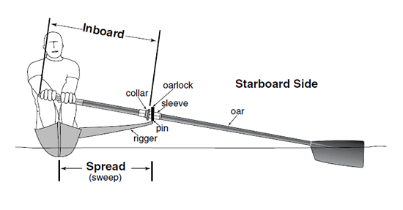

Image 1: Composition of a Sweep Boat

Image 2: Composition of a Sculling Boat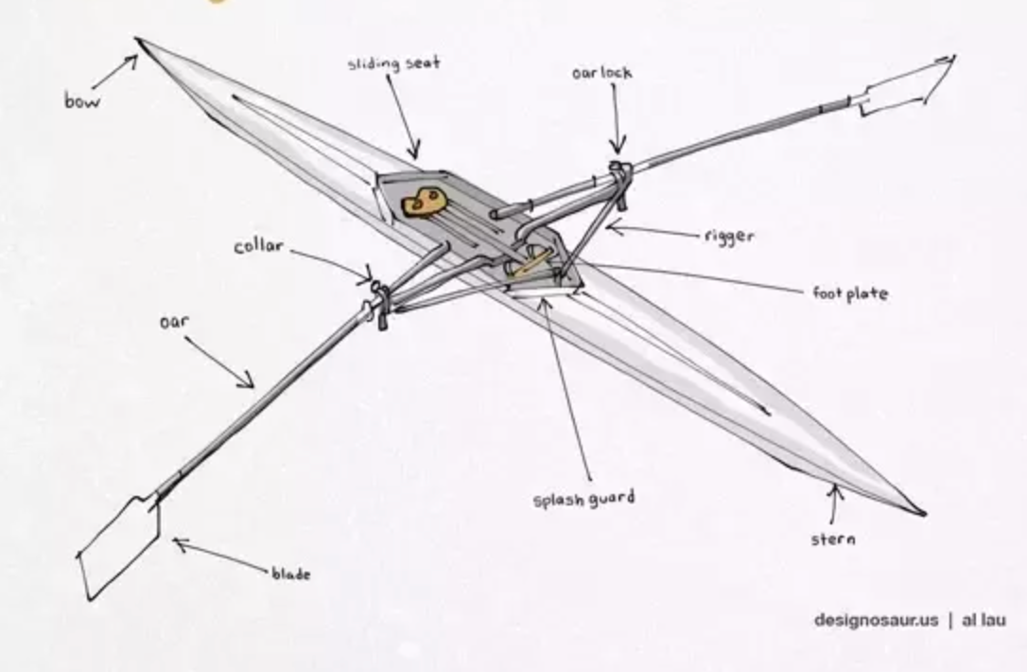

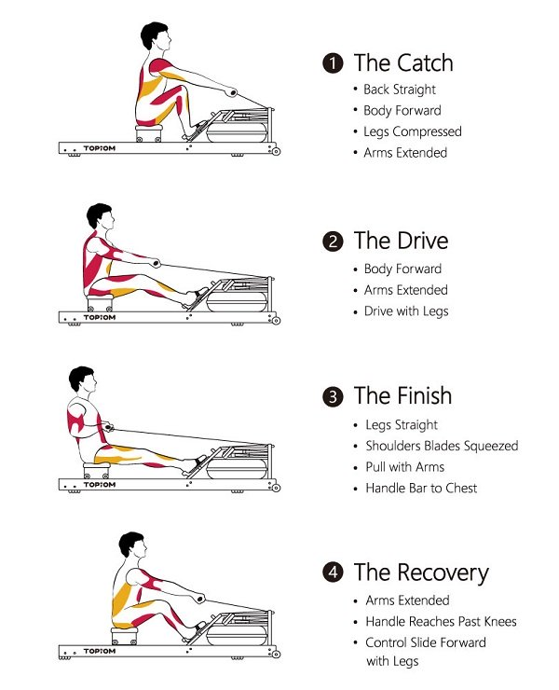

Image 3: Composition of a rowing stroke

## Appendix A – Safe Sport

“The Purpose of the Rule of Two: To protect minor athletes and coaches in potentially vulnerable situations by ensuring more than one adult is present.” (Coaching Association of Canada)

## 

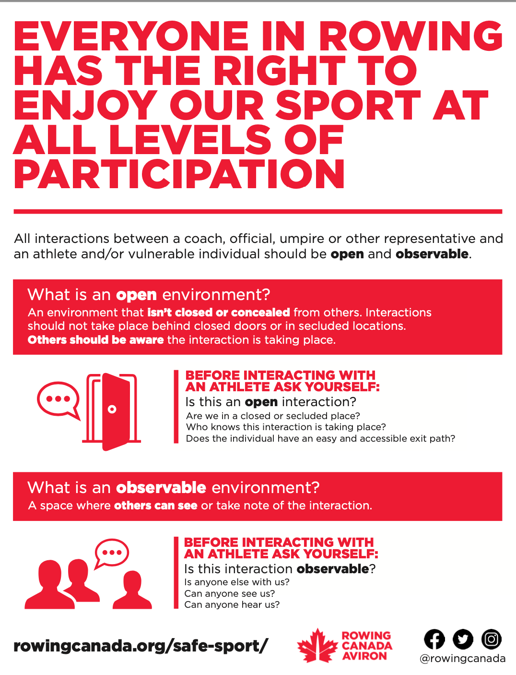

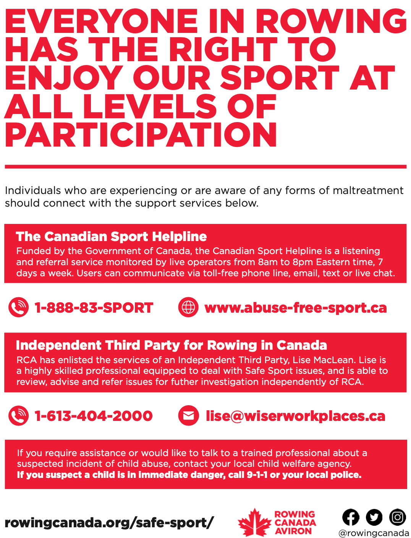

## Appendix B – COVID-19

GBRC is committed to keeping all members safe and following all provincial and municipal guidelines.

Due to the ever changing nature of COVID restrictions, all requirements will be communicated via email to club members as they arise.

GBRC encourages all members to wear masks in the boat house or when physical distancing is not an option. All members are required to be open and honest about symptoms and exposure, and are not permitted to come to the boathouse if they have tested positive or have symptoms, regardless of vaccine status.

GBRC also acknowledges the political nature of COVID-19 and will not tolerate imposition of ideas or conflict arising as a result of discussion on mandates. For comfort of members, members may ask vaccination status when deciding crew boats (i.e., if one is not comfortable rowing in a crew boat with someone of a different vaccine status), but conflict may not arise as a result, from any party.

All members of GBRC are bound to the Code of Conduct and must be respectful of individual choices.

1. See Appendix A
2. All GBRC members are expected to assist with the Muskoka Fall Classic (MFC) Regatta on the day before the regatta or on the day of the regatta, whether or not they are on the committee. The MFC is our biggest fundraiser and requires as much help as possible to run a successful event.